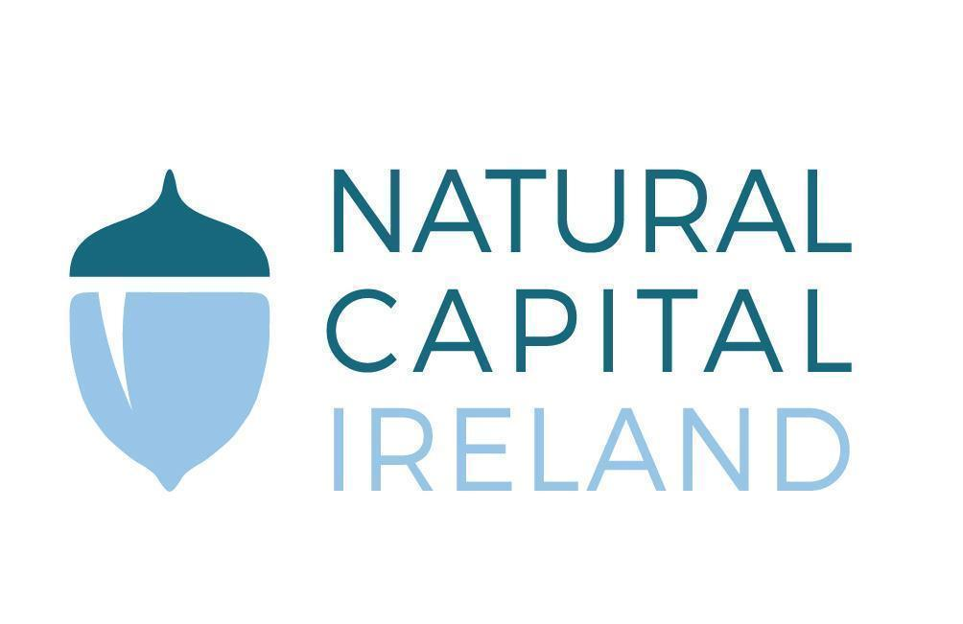

Developing the Natural Capital approach to value, protect and restore Ireland’s natural resources

Natural Capital Ireland

Pre-budget submission 2024

Contents
Overview Summary of Recommendations 3
Background information on Natural Capital Ireland and natural capital accounting 4
Detailed Recommendations 6
1. Invest in actions that support the development of national natural capital accounts (NCA) for the island of Ireland 6
2. Develop central guidance through the Public Spending Code on valuing natural capital assets, biodiversity and ecosystem services 7
3. Support the development of Ireland’s Business for Biodiversity Platform and incentivise the business transition to nature positive 8
Conclusion 10
References 10

Overview Summary of Recommendations
In this submission, Natural Capital Ireland recommends to Government the following priorities for investment in Budget 2024 and subsequent budgets:
- Invest in actions that support the development of national natural capital accounts for the island of Ireland
- Set financial spending targets for the development and implementation of national natural capital accounting
- Support the further development of a network of experts in natural capital accounting for the island of Ireland
- Require and enable collaboration between relevant bodies to advance natural capital accounting and reporting methods and standards in Ireland, in line with the UN-adopted standard System of Environmental Economic Accounting (SEEA) and ensure that appropriate guidance is provided to key sectors on use of natural capital accounting
- Invest in Ireland’s nature data to support this work
- Support relevant organisations, including the Central Statistics Office (CSO), in a national assessment of our natural capital stocks and flows to identify priority ecosystems and threats to natural capital using appropriate tools, to be coordinated with relevant authorities in Northern Ireland.

- Develop central guidance through the Public Spending Code on valuing natural capital assets, biodiversity and ecosystem services
- Build on outputs of the EPA-funded Irish Natural Capital for Sustainable Environments (INCASE) project, CSO Ecosystem Accounting Division (EAD) research, and work by Stephen Hynes of the Socio-Economic Marine Research Unit at University of Galway on valuing Ireland's Ocean Economy, to develop central guidance on valuing our natural capital.

- Support the development of Ireland’s Business for Biodiversity Platform (BFBI) and incentivise the business transition to nature:
- Help businesses to conduct materiality assessments and determine their impacts and dependencies on nature and biodiversity
- Produce guidance for Irish businesses on relevant international initiatives such as the Taskforce for Nature-related Financial Disclosures (TNFD) and Science-based Targets for Nature (SBTN) to ensure they are compliant with new legislation such as the EU Corporate Sustainability Reporting Directive (CSRD).
- Align with current ongoing initiatives such as the All-Ireland Pollinator Plan and Climate Toolkit 4 Business to provide coordinated inputs into biodiversity actions to contribute to the achievement of the fourth National Biodiversity Action Plan.

Background on Natural Capital Ireland and natural capital accounting
Natural Capital Ireland (NCI) wishes to make this Pre-budget 2024 submission with recommendations for the protection of our natural capital. NCI is a not-for-profit organisation leading the national conversation on natural capital (view our website here). We are a group of organisations and individuals from academia and the public, private and NGO sectors, committed to the development and application of the natural capital approach to policy and decision-making.
Our mission is to value, protect and restore Ireland’s natural capital and ecosystem services, through supporting the adoption of the natural capital approach in public policy and corporate strategy, promoting informed public and private sector decision-making, and assisting in the establishment of a national natural capital accounting standard, providing a tool for the integration of the many values of Ireland's natural capital into our national accounts.
Natural capital refers to Ireland’s stock of natural assets such as soil, forests, rivers and the marine, and the associated flow of ecosystem services that benefit and support Irish citizens. Ireland’s national accounts and policies do not currently take account of our natural capital, despite it being the foundation of our social and economic capitals, as reflected by the nested Sustainable Development Goals (SDGs) (Figure 1). This omission in policy drives ecosystem degradation, species loss and pollution, all of which undermine Ireland’s economic viability and community health and wellbeing.
Natural capital accounting is now a key focus of European and national policy, strategy and regulation, including the EU Green Deal, EU Biodiversity Strategy 2030, National Development Plan 2021-2030, Ireland’s 3rd National Biodiversity Action Plan 2017-2021 and the soon-to-be-published 4th National Biodiversity Action Plan (2023-2027).

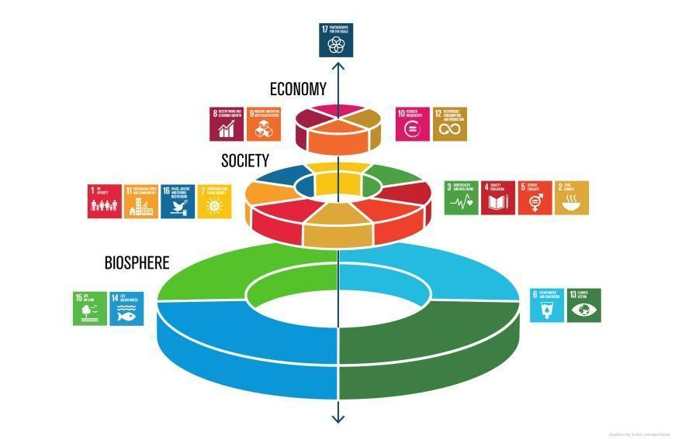

Figure 1. The Sustainable Development Goals “wedding cake” showing how nature underpins all other aspects of society. Credit: Azote for Stockholm Resilience Centre, Stockholm University CC BY-ND 3.0
How the Natural Capital Accounting Method Works
Natural capital accounting tools such as the UN's statistical standard System of Environmental Economic Accounting Framework (SEEA) and System of Environmental Economic Accounting – Ecosystem Accounting (SEEA-EA), allow us to map the extent and condition of ecosystems and their associated ecosystem services from the river catchment to national level. Ecosystem services cover areas important to climate action and human health, including carbon sequestration, water quality, flood and heat mitigation, biodiversity and pollination for crops, clean air, amenities for recreation, important for tourism, and physical and mental health. Natural capital accounts show changes in the extent and ecological condition of our natural assets and ecosystem services over time and can be used to inform decisions on national policy relating to land-use, health, climate change mitigation and adaptation, energy, transport, taxation, education, homelessness, development.
Natural capital accounting for ecosystem accounts can organise habitat and landscape data and measure ecosystem services in physical and monetary terms, tracking changes in the condition and extent of ecosystem assets and linking this information to economic and other human activity (UN Statistical Commission, 2022). While monetary values may not be appropriate for use in all decision-making contexts, measuring our natural capital in monetary terms can be useful to communicate benefits of investment in climate and biodiversity loss mitigation measures and enhance decision-making ability. When integrated with the system of national accounting, natural capital accounts make visible the true economic cost of continuing to degrade nature and can inform new roadmaps toward a safer, healthier and more economically viable future for all.
A number of research projects in Ireland relating to natural capital accounting include the INCASE Project which trialled the SEEA-EA at catchment scale; the ForES Project which is developing natural capital accounts for forest site scale; Farm Zero C Project which is a collaboration with Trinity College Dublin, BiOrbic Centre, Carbery Group and others addressing carbon neutral farming; and Nature+ Energy which is working at the wind farm scale. There is a need to build capacity nationally via such research projects.
Natural capital research projects have revealed knowledge and data gaps and identified priority areas which can be addressed in the short, medium, and long-term to enable increased accuracy and efficiency of natural capital accounting in Ireland. The INCASE Project, which concluded in April 2023, developed natural capital accounts at river catchment scale at four locations across Ireland to support the implementation of the EU Water Framework Directive. This involved accounting for ecosystem services across a range of land cover areas including, agricultural, peatlands, freshwater systems, forests, industrial and urban sites. The INCASE project final report provides the template example for developing natural capital accounts at various scale in Ireland.
We need to build capacity to deliver on Ireland’s obligations to compile national natural capital accounts using the SEEA and SEEA-EA frameworks, including upskilling, training, and building natural capital into the education system. The CSO Ecosystem Accounts Division, set up in 2020, has begun to compile extent and condition accounts as part of its SEEA-EA implementation and will require further resourcing to develop this work.
We set out below our three recommendations to Government in relation to natural capital accounting in Ireland.

Detailed Recommendations
Natural Capital Ireland recommends that the Department of Public Expenditure and Reform:

Invest in actions that support the development of national natural capital accounts (NCA) for the island of Ireland
- Set financial spending targets for the development and implementation of national natural capital accounting.
- Invest in the further development of a network of experts in natural capital accounting for the island of Ireland.
- Incorporate a natural capital approach in policy decisions in line with the System of Environmental Economic Accounting-Central Framework (SEEA) and the System of Environmental Economic Accounting-Ecosystem Accounting (SEEA-EA).
- Require and enable collaboration between relevant bodies including the CSO and departments including Department of Public Expenditure, Department of Finance, Department of Housing, Local Government & Heritage and Department of Environment, Climate and Communications, with dedicated staff, training and ongoing support to advance natural capital accounting and reporting methods and standards in Ireland, and ensure that appropriate guidance is provided to key sectors.
- Invest in improving Ireland’s nature-related data as laid out in the 2021 Data 4 Nature conference recommendations.
- Support relevant organisations, including NCI and the CSO, in a national assessment of stocks, flows and trends in ecosystem services (which are part of our natural capital) to identify priority ecosystems and threats to natural capital using appropriate tools, to be coordinated with relevant authorities in Northern Ireland.
- Fund research projects and training in the area of natural capital and natural capital accounting, similar to the INCASE project, to cover large scale research project costs of €0.5-1.5million with a capital expenditure package ring-fenced for this purpose. Ireland does not currently have the capacity or expertise in natural capital, or natural capital accounting, to meet its legal obligations outlined in this document. Commitment to adequate funding and support is necessary for projects to address natural capital knowledge gaps and establish where losses are occurring to enable further research on scaling the application of the System of Environmental Economic Accounting and SEEA-Ecosystem Accounting in different contexts.
Policies relating to Recommendation 1
The European Green Deal states that “all EU policies should contribute to preserving and restoring Europe’s natural capital” and that it will support businesses and other stakeholders in developing standardised natural capital accounting practices within the EU and internationally (EC, 2019). A national assessment of Ireland’s natural capital will support the development and implementation of natural capital accounting tools.
The EU Biodiversity Strategy 2030 outlines aims to protect, conserve and enhance Europe’s natural capital, and protect health and well-being from environment related risks and impacts. The development of standardised natural capital accounting practices was explicitly mentioned as part of the range of initiatives to pursue green finance and investment. The EU Biodiversity Strategy 2030 aims to ‘create job opportunities, reconcile economic activities with nature and help maintain the productivity and value of our natural capital in the long run’ (EC, 2021). The Strategy also introduces a new EU Nature Restoration Law to restore ecosystems for people, the climate and the planet and aid alignment of national policy with European policy.
The proposed 2022 EU amended regulation (No 691/2011) on European Environmental Economic Accounts, which will mandate the compilation of ecosystem accounts, has been approved by the EU Commission and is currently with the European Parliament and Council for final approval. The SEEA and SEEA-EA frameworks require economic reporting to go beyond Gross Domestic Product (GDP) and will ensure that natural capital, including our forests, wetlands and other ecosystems, will be accounted for in economic reporting.
The National Adaptation Framework cites natural capital as one of four key thematic areas for development of sectoral adaptation plans for climate resilience in Ireland. ( see Chp 3).
Heritage Ireland 2030 mentions natural capital in the context of biodiversity and recommends using the natural capital approach to emphasise environmental risk and opportunity in economic systems, so that dependencies on our natural assets are embedded in our policies, plans and actions.
Ireland’s Climate Action Plan 2023 recognises the importance of rehabilitating degraded peatlands to a ‘condition in which they regain their ability to deliver specific ecosystem services’ and to allow mitigation gains initially and carbon sequestration in the future, areas all stressed in the plan (17.3.6 Peatland Rehabilitation). The plan highlights the importance of the Bioeconomy so that our biological resources are used sustainably, and non-renewable and fossil fuel products are displaced by using our natural capital more efficiently and sustainably (Climate Action Plan, 2023, 11.2.5 The Bioeconomy).
The EU Circular Economy Action Plan (CEAP) (EC, 2020) and updated EU Bioeconomy Strategy (EC, 2018) both make clear commitments to the protection of natural capital.

Develop central guidance through the Public Spending Code on valuing natural capital assets, biodiversity and ecosystem services
The Public Spending Code is used by Government to assess the climate and environmental consequences of capital investment decisions. The National Development Plan 2021-2030 states that the Department of Public Expenditure and Reform has long-term plans to develop guidance on valuing biodiversity and ecosystem services by drawing on the 4th National Biodiversity Action Plan.
We recommend that such guidance is delivered as a matter of urgency, building on results from the Irish Natural Capital Accounting for Sustainable Environments (INCASE) project, as well as CSO Ecosystem Accounting Division (EAD) research, and work by Stephen Hynes of the Socio-Economic Marine Research Unit at University of Galway on valuing Ireland's Ocean Economy.
In addition, Project Ireland 2040’s National Planning Framework places the protection, conservation and enhancement of our natural capital in the context of both sustainable water management and planning of green infrastructure (see Chp 9). National Policy Objective 52 dictates that development must occur within environmental limits, adhering to both the relevant environmental legislation and the sustainable management of our natural capital. Central guidance through the Public Spending Code on valuing biodiversity and ecosystem services will help to meet this objective.

Support the development of Ireland’s Business for Biodiversity Platform and incentivise the business transition to nature positive

Government funding (up to €350K p.a with a 5% inflationary increase year on year) is needed, with a funding review every three years, in order to fund adequate staff and resources for the platform to fulfil and maintain the following functions -
- Help businesses to conduct materiality assessments and determine their impacts and dependencies on nature and biodiversity.
- Produce evolving guidance for Irish businesses, including documents, practical resources and workshops, on relevant international initiatives such as the Taskforce for Nature-related Financial Disclosures (TNFD) and Science-based Targets for Nature (SBTN), building a roadmap to help businesses understand how the different frameworks interact and when and how to use them based on the business context, to ensure that they are compliant with new legislation such as the EU Corporate Sustainability Reporting Directive (CSRD).
- Align with current ongoing initiatives such as the All-Ireland Pollinator Plan and Climate Toolkit 4 Business to provide coordinated biodiversity actions to contribute to the achievement of the fourth National Biodiversity Action Plan.
Additional information on Recommendation 3
NCI is currently aiding in developing the Business for Biodiversity Ireland (BFBI) Platform with initial seed funding from the National Parks & Wildlife Service and Department of Agriculture, Food and the Marine. Established in 2022, the Platform is supporting Irish businesses to assess and disclose their impacts and dependencies on biodiversity, at present, with only one dedicated staff member and part-time support from NCI. If properly resourced with sustained funding, this platform has huge potential to help implement three Citizens' Assembly on Biodiversity Loss recommendations:
  - Recommendation 17: The Irish business community needs to engage with biodiversity and show leadership in the same way that they have begun to engage with the issue of the climate crisis.
  - Recommendation 156: In addition to actions around the climate crisis, businesses should be required to take biodiversity into account through programmes which promote industry’s engagement with biodiversity.
  - Recommendation 159: All large businesses and financial organisations must develop a mandatory assessment and disclosure process of harmful impacts to biodiversity, with a mandated role (similar to a Health and Safety or Well-being Officer).
In addition, BFBI can support implementation of two business-related targets under the post-2020 Global Biodiversity Framework:
  - Target 15: Take legal, administrative or policy measures to encourage and enable business, and in particular to ensure that large and transnational companies and financial institutions:
    - Regularly monitor, assess, and transparently disclose their risks, dependencies and impacts on biodiversity, including with requirements for all large as well as transnational companies and financial institutions along their operations, supply and value chains, and portfolios;
    - Provide information needed to consumers to promote sustainable consumption patterns;
    - Report on compliance with access and benefit-sharing regulations and measures, as applicable;
    - In order to progressively reduce negative impacts on biodiversity, increase positive impacts, reduce biodiversity-related risks to business and financial institutions, and promote actions to ensure sustainable patterns of production.
  - Target 18: Identify by 2025, and eliminate, phase out or reform incentives, including subsidies, harmful for biodiversity, in a proportionate, just, fair, effective and equitable way, while substantially and progressively reducing them by at least $500 billion per year by 2030, starting with the most harmful incentives, and scale up positive incentives for the conservation and sustainable use of biodiversity.
Business for Biodiversity Ireland can support businesses in their compliance with the EU Corporate Sustainability Reporting Directive (CSRD), in particular around the European Sustainability Standard (ESRS) E4 on Biodiversity and Ecosystems. The Platform can also help businesses positively contribute to the delivery of targets within the SDG Framework, specifically Goal 12 (Responsible Production and Consumption), Goal 13 (Climate Change), Goal 14 (Life Below Water) and Goal 15 (Life on Land).
Implementing NCI’s Pre-Budget 2024 recommendations will help to address the biodiversity loss crisis
In addition to delivering on Ireland’s obligations to develop and implement national natural capital accounts, implementation of the three recommendations outlined above will help deliver on the recommendations of the Citizens' Assembly on Biodiversity Loss Report (2022) which sets out the actions needed to reverse the dangerous trend of biodiversity loss in Ireland. Biodiversity, a central component of natural capital, is a measure of biological variation at the genetic, species and ecosystem level. Biodiversity is linked to ecosystem resilience, acting to stabilise ecosystem functioning and the provision of ecosystem services in the face of environmental change.
NCI has been working as part of a consortium to support the National Parks and Wildlife Service in drafting the 4th National Biodiversity Plan, which will be finalised later this year. We recommend the adequate resourcing of all actions set out in the 4th National Biodiversity Action Plan in line with recommendation No. 21 in the Report of the Citizens' Assembly on Biodiversity Loss which states that “there must be a whole of State approach to drafting and implementing a new statutory National Biodiversity Plan, aligned with the Climate Action Plan, supported by legislation and properly funded”.
Furthermore, in February 2023 the UN Convention on Biological Diversity secretariat released the post-2020 Global Biodiversity Framework (GBF), including the following target:
GBF TARGET 14: Ensure the full integration of biodiversity and its multiple values into policies, regulations, planning and development processes, poverty eradication strategies, strategic environmental assessments, environmental impact assessments and, as appropriate, national accounting, within and across all levels of government and across all sectors, in particular those with significant impacts on biodiversity, progressively aligning all relevant public and private activities, fiscal and financial flows with the goals and targets of this framework.

Conclusion
We hope you find the points above offer opportunities to expand, deepen and co-ordinate policies across the whole range of economic, environmental, social and cultural values, and we would welcome the opportunity to work closely with the Government to deliver on a budget that values and accounts for Ireland’s natural capital. We will be in touch to invite you to upcoming natural capital briefing events to learn more. Please contact us for clarifications, and further information at researchteam@naturalcapitalireland.com

Natural Capital Ireland

References
European Commission (EC), 2021. EU Biodiversity Strategy for 2030 - Bringing nature back into our lives. Luxembourg: Publications Office of the European Union. Available online: https://op.europa.eu/en/publication-detail/-/publication/31e4609f-b91e-11eb-8aca-01aa75ed71a1 [accessed July 2023]
European Commission (EC), 2019. Communication from the Commission: The European Green Deal, 11 December 2019. Available online: https://eur-lex.europa.eu/legal-content/EN/TXT/HTML/?uri=CELEX:52019DC0640&from=ET [accessed April 2023]
UN Statistical Commission, 2022 Global Assessment of Environmental-Economic Accounting and Supporting Statistics 2022. Background document. Prepared by the UN Statistics Division under the auspices of the Committee of Experts on Environmental-Economic Accounting. Available online: https://seea.un.org/sites/seea.un.org/files/global_assessment_2022_background_doc_v4_clean_0.pdf [accessed July 2023]

Natural capital is an economic metaphor for nature, which includes all biotic and abiotic entities and processes that constitute the planet earth including plants, rocks, animals, insects, water, gases etc. and their interactions with each other.
Ecosystem services: The outputs from ecosystems which have a benefit and value to human wellbeing. Defined to categories including: Provisioning Services such as food and water; Regulating Services such as climate and pollination; Supporting Services such as soil nutrient cycling; and Cultural Services such as educational, aesthetic and cultural heritage including recreation and tourism. (MA, 2005)
System of Environmental Economic Accounting (SEEA) is an international statistical standard to account for nature and its relationship with the economy. Website: https://seea.un.org/
System of Environmental Economic Accounting (SEEA-EA) is a integrated statistical framework for organising biophysical data (habitats and landscapes), measuring ecosystem services in physical and monetary terms, tracking changes in the condition and extent of ecosystem assets and linking this information to economic and other human activity. Website: https://seea.un.org/ecosystem-accounting
Natural Capital Accounting (NCA) is an umbrella term covering efforts to use an accounting framework which provides a systematic way to measure and report on stocks and flows of natural capital. It covers accounting for individual environmental assets or resources, both living and non-living (e.g. minerals, timber, and energy), as well as accounting for ecosystem assets (e.g. forests, wetlands), biodiversity and ecosystem services. SEEA and SEEA-EA can both be considered components of NCA. (CSO definition).
Natural Capital Ireland (NCI), 2021. Data 4 Nature Workshop Report. Available online: https://www.naturalcapitalireland.com/_files/ugd/94066f_9cdc0d494b734b06ac6be6a9007e9dc5.pdf [accessed July 2023]

